**KAMPALA PARENTS’ SCHOOL 2004**

**P.7 INTERNAL MOCK 2024.**

**SOCIAL STUDIES & RELIGIOUS EDUCATION**

***Time Allowed: 2 hours 15 minutes***

|  |  |  |  |  |  |  |  |  |  |
| --- | --- | --- | --- | --- | --- | --- | --- | --- | --- |
| **Random No.** | | | | | | | **Personal No.** | | |
|  |  |  |  |  |  |  |  |  |  |

**Index No.**

**Candidate’s Name:** ………………………………………………………………….………………

**Candidate’s Signature:** ……………………………………………………………………………

**School Random No.** ………………………………………………………………….………………

**District ID:** ………………………………………………………………...………………………………

**Read the following instructions carefully:**

|  |  |  |
| --- | --- | --- |
| **FOR EXAMINER’S USE ONLY** | | |
| **Qn. No** | **MARK** | **EXR’S NO.** |
| **1 – 10** |  |  |
| **11– 20** |  |  |
| **21 – 30** |  |  |
| **31 – 40** |  |  |
| **41 – 43** |  |  |
| **44 – 46** |  |  |
| **47 – 49** |  |  |
| **50 – 52** |  |  |
| **53 – 55** |  |  |
| **TOTAL** |  |  |

1. Do not write your **school** of **district** name

anywhere on this paper.

1. This paper has two sections: **A** and **B**.

Section **A** has **40** questions and section **B** has

**15** questions.

1. Answer **all** questions. **All** answers to both

sections **A** and **B** must be written in the

spaces provided.

1. All answers **must** be written using a **blue** or **black** ball point pen or ink. Any work written in pencil will **not** be marked.
2. Unnecessary **changes** in your work and handwriting that cannot be easily read may lead to **loss of marks.**
3. Do not fill anything in the table indicated:

**ʺfor examiner’s use only** and boxes

inside the question paper.

**SECTION**

1. What is a homestead?

_____________________________________________________________

1. Give a reason why wetlands should be protected.

_____________________________________________________________

1. Why is a Stevenson screen built with louvres?

_____________________________________________________________

1. How did the expulsion of Asians from Uganda in 1972 affect Uganda’s economy?

_____________________________________________________________

1. Give any one advantage of clonal coffee over Arabica coffee.

_____________________________________________________________

1. **Draw the map symbol of a canal.**

1. Give any one effect of the rotation of the earth.

_____________________________________________________________

1. How does UNICEF promote the welfare of children?

_____________________________________________________________

1. State one-way security promotes the tourism industry in Uganda.

_____________________________________________________________

1. Name the court that serves the East African Community Member states.

_____________________________________________________________

1. How does the distance from the equator influence climate of Africa?

_____________________________________________________________

1. Apart from stopping slave trade, state any one way missionaries contributed to the social life of the people of East Africa.

_____________________________________________________________

1. Why are minerals regarded as non-renewable resource?

_____________________________________________________________

1. Mention the only bantu kingdom in Kenya.

_____________________________________________________________

1. How does extending electricity in villages promote development?

_____________________________________________________________

1. State any one way the African Union has tried to promote peace in Africa.

_____________________________________________________________

1. **Name the road sign below.**

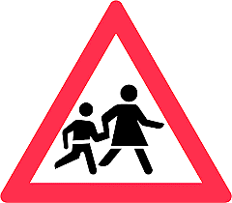

_______________________________________________

1. Give any one example of a service industry.

_____________________________________________________________

1. State any one-way slave trade slowed the development of East Africa.

_____________________________________________________________

1. Of what importance is the Central bank to commercial banks?

_____________________________________________________________

1. Mention the plantation crop grown both in Kalangala district and Nigeria.

_____________________________________________________________

1. What is tributary?

__________________________________________________________________________________________________________________________

1. Give a reason why the government discourages the division of land into small plots.

_____________________________________________________________

1. State one way Uganda benefitted from hosting the Common Wealth Heads of Government Meeting(CHOGM) in 2007.

_____________________________________________________________

1. Why is corruption regarded as a bad practice?

_____________________________________________________________

1. How were pre-colonial societies organized economically?

_____________________________________________________________

1. State any one similarity between the role of the Chief Administrative Officer and the permanent secretary in the ministry.

_____________________________________________________________

1. Why were the Baganda against the formation of the East African Federation?

_____________________________________________________________

1. How is the Uganda flag treated when a country is in National mourning?

____________________________________________________________

1. Why are winding roads common in the Kigezi region of Uganda?

_____________________________________________________________

1. What role did Emperor Haile Selassie play towards the formation of OAU?

_____________________________________________________________

1. Give a reason why Tanzam railway was built in Tanganyika.

_____________________________________________________________

1. Why was it necessary to introduce money to replace barter trade?

_____________________________________________________________

1. How did the introduction of formal education speed up the demand for independence in Africa?

_____________________________________________________________

1. Mention the body that checks on the quality of goods in Uganda.

_____________________________________________________________

**For each of the questions 36 – 40, answer either Christianity or Islam but not both in the same number.**

1. **Either:** Give a reason why Christians are encouraged to pay tithe.

_____________________________________________________________

**Or:** Give a reason why Muslims are encouraged to pay zakat?

_____________________________________________________________

1. **Either:** Mention any one problem the Israelites faced during Exodus.

_____________________________________________________________

**Or:** mention any one problem the Ban-Israelites faced during Exodus.

_____________________________________________________________

1. **Either:** How did St. Stephen meet his death?

_____________________________________________________________

**Or:** How did Sumayyah meet her death?

_____________________________________________________________

1. **Either:** State one difference between angels and prophets.

_____________________________________________________________

**Or:** State one differences between angels and prophets.

_____________________________________________________________

1. **Either:** Why are Christians encouraged to value work?

__________________________________________________________________________________________________________________________

**Or:** Why are Muslims encouraged to value work?

__________________________________________________________________________________________________________________________

**SECTION B**

1. a) What is children rights?

__________________________________________________________________________________________________________________________

1. Give any two ways the government has promoted the children’s right to education.
2. _____________________________________________________________
3. _____________________________________________________________
4. Give a reason why children’s rights should be protected.

_____________________________________________________________

1. Study how Mr. Tenywa spends his monthly income of shs.2000000 and answer questions that follow.

(i)food shs.450000=

(ii)transport shs.200000=

(iii)school fees shs500000=

(iv)medical shs300000=

(v)clothes shs.350000=

(vi)others shs.100000=

1. What is Mr. Tenywa’s monthly expenditure?

____________________________________________________________________

b) What type of budget does Mr. Tenywa prepare?

____________________________________________________________________

c) Give a reason to support your answer in (b)above.

____________________________________________________________________

d)State one advantage of preparing the above type of budget.

____________________________________________________________________

1. a) Write Legco in full.

__________________________________________________________________________________________________________________________

1. Name the colonial governor who promoted the formation of Legco in Uganda.

_____________________________________________________________

1. Mention the first African to join Legco in Central Uganda.

_____________________________________________________________

1. Why were Africans not happy with Legco before 1945?  
   _____________________________________________________________
2. Study the rainfall formation below and answer questions that follow.

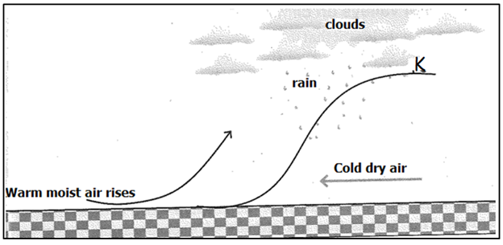

a) Mention the type of rainfall formation shown above.

_____________________________________________________________

b) Name the feature marked **K**.

_____________________________________________________________

c) How is the above type of rainfall formed?

____________________________________________________________

d) Mention any one district in Uganda that receives the above type of rainfall.

_____________________________________________________________

1. a) Which international Organization was formed immediately after the end of first world war?

____________________________________________________________

(b)Why was the above organization in (a) formed?

_____________________________________________________________

1. State two ways refugees benefit from the United Nations High Commissioner for Refugees. (UNHCR)
2. __________________________________________________________
3. __________________________________________________________
4. a) What name was given to the trade that was conducted between the Arabs and the people of the interior of East Africa?

_____________________________________________________________

(b)Mention any two trade items that were picked from the interior of East Africa.

1. __________________________________________________________
2. __________________________________________________________
3. How did **Mirambo** benefit from that trade above in (a)?

__________________________________________________________

1. **Study the map below and answer questions that follow.**
2. 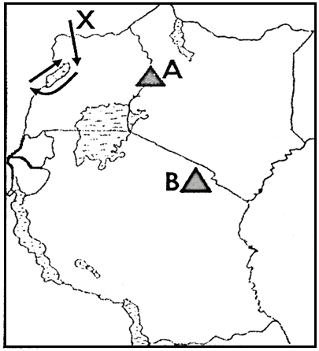Name the European explorer who discovered mountain marked **A**. _____________________________________
3. Why did the European explorer who used route marked **X** come to Uganda**?**

____________________________________________________________________________________________

1. Use letter **T** to show Lake Malawi.
2. How are the people who live on mountain **A** and mountain **B** similar in terms of occupation?

i)____________________________________________

­­­­­­­­­­­­­­­­­­__________________________________________________________________________

ii)__________________________________________________________________________

1. a) Mention the rebellion in Kenya that was staged by the Kikuyu against the British.

_____________________________________________________________

1. Give any two reasons why the above rebellion took long to end.
2. _____________________________________________________________
3. _____________________________________________________________
4. How did the Kikuyu people benefit from the above rebellion?

_____________________________________________________________

1. In which country of East Africa are Miombo woodlands?

_____________________________________________________________

(b)Give any two reasons why Miombo woodlands are not suitable for human settlement.

(i)_______________________________________________________

(ii)_____________________________________________________

(c)Mention the body in Uganda responsible for environmental conservation.

__________________________________________________________

1. Study the map below and answer questions that follow.

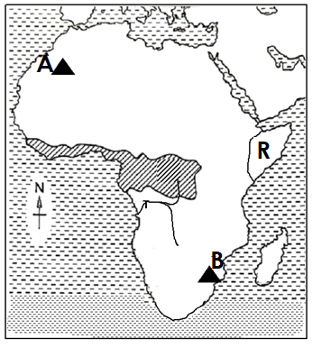a) Why does river marked **T** carry the largest

volume of water to the Sea?

_____________________________________

_____________________________________

b) To which economic grouping does country marked R belong?

_____________________________________

_____________________________________

c) Describe the climatic region shaded on the map.

___________________________________________________________

d) How was the formation of mountain **B** different from mountain **A**?

___________________________________________________________

___________________________________________________________

For questions 51- 54 answer either Christianity or Islam but not both in a number.

1. **Either: Match items in A and B correctly.**

**A** **B**

1. Joseph of Arimathea. Doubted the resurrection of Jesus.
2. Simon Peter helped Jesus to carry the cross.
3. Simon of Cyrene buried Jesus Christ.
4. Thomas Denied Jesus three times.
5. Joseph of Arimathea: _____________________________________
6. Simon Peter: ______________________________________
7. Simon of Cyrene: _____________________________________
8. Thomas: ______________________________________

**Or: Match items in A and B correctly.**

**A** **B**

1. Khadijah Close friend of Prophet Muhammad.
2. Abubakar Wife of Prophet Muhammad.
3. Abdallah Mother of Prophet Muhammad.
4. Amina Father of Prophet Muhammad.
5. Khadijah: ______________________________________
6. Abubakar: ______________________________________
7. Abdallah: ______________________________________
8. Amina: ______________________________________
9. **Either:**
10. What is the last book in the Bible?

__________________________________________________________

1. Give two ways a Quran is similar to a Bible.
2. __________________________________________________________
3. __________________________________________________________
4. State one use of a Bible to a p.7 pupil.

__________________________________________________________

**Or**: a) Name the last chapter in the Quran.

_________________________________________________________

b) Give two ways a Quran is similar to a Bible.

i) ________________________________________________________

ii) _________________________________________________________

c) State one use of a Quran to a p.7 pupil.

__________________________________________________________

1. **Either:**
2. What is success?

__________________________________________________________

1. Mention any two things that helped Jesus to succeed on earth.
2. __________________________________________________________
3. __________________________________________________________
4. Give one reason why some Christians fail at their places of work.

__________________________________________________________

**Or:**

* + 1. What is success?

__________________________________________________________

* + 1. Mention any two things that helped prophet Muhammad to succeed on earth.

1. __________________________________________________________
2. __________________________________________________________
   * 1. Give one reason why some Muslims fail at their places of work.

__________________________________________________________

1. **Either:**
2. Which prayer did Jesus teach His apostles?

__________________________________________________________

1. Give a reason why Christians perform the prayers below.

i) Thanks giving? _____________________________________________________________

ii) Intercession prayers?

_____________________________________________________________

1. State any one lesson we learn from Jesus ‘prayerful life.

___________________________________________________________

**Or:**

1. Which prayer do Muslims perform at night during Ramadhan?

__________________________________________________________

1. Give a reason why Muslims perform the prayers below.
2. Subhr prayer?

_________________________________________________________

ii) Ishah?

___________________________________________________________

c)What lesson do we learn from Prophet Muhammad’s prayerful life?

___________________________________________________________

1. **Both:**
2. What is Sexual deviation?

____________________________________________________________________________________________________________________

1. Mention any two acts of Sexual deviation.
2. __________________________________________________________
3. __________________________________________________________
4. State any one danger of Sexual deviation.

__________________________________________________________

**\*\*\*\*Good luck\*\*\*\***